RESOLUTION NO.__________

RE: CERTIFICATE OF APPROPRIATENESS UNDER THE

PROVISIONS OF THE ACT OF THE PENNSYLVANIA

LEGISLATURE 1961, JUNE 13, P.L. 282 (53

SECTION 8004) AND BETHLEHEM ORDINANCE NO.

3952 AS AMENDED.

WHEREAS, it is proposed to install siding in the rear at 212 E. Fourth St.

NOW, THEREFORE, BE IT RESOLVED by the Council of the City of Bethlehem that a Certificate of Appropriateness is hereby granted for the work.

Sponsored by: (s)

(s)

ADOPTED BY COUNCIL THIS DAY OF

(s)

President of Council

ATTEST:

(s)

City Clerk

HISTORIC CONSERVATION COMMISSION

CASE # 512– It is proposed to install siding in the rear at 212 E. Fourth St.

OWNER/APPLICANT: Erig & Rosemary Frey

The Commission upon motion by Mr. Roeder seconded by Mr. Lader adopted the proposal that City Council issue a Certificate of Appropriateness for the proposed work described herein:

1. The proposal to install siding in the rear at 212 E. Fourth St. was presented by Erig & Rosemary Frey.
2. The new siding will be fiber cement siding (not vinyl) with 4” exposure, prefinished in a tan close to the tan color on the house or unfinished and painted to match the house color.
3. The siding will be installed at the rear of the house where it is not highly visible from the street.
4. If possible the siding will be smooth and not wood grained. If wood grained texture is the only option it will be acceptable.
5. The proposed motion was unanimously approved.

CU: cu

By:

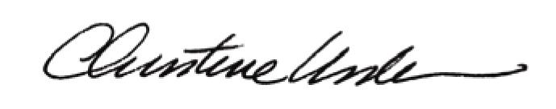

Date of Meeting: September 15, 2014 Title: Historic Officer